|  |  |  |  |  |  |  |  |  |
| --- | --- | --- | --- | --- | --- | --- | --- | --- |
|  | | | | | | | | |
|  | | AWS Lab 5 | | | | |  | |
|  |  | | | | | | |  |
|  | | | |  |  | | | |
|  | | | | Weizhen Chen |  | | | |
|  | | | | —CCNP—Jeffery Mason &Michael Hansen |  | | | |
|  | | |  | | |  | | |

# **Lab 5: Build Your DB Server and Interact with Your DB Using an App**

**Amazon Relational Database Service** (Amazon RDS)

Amazon Relational Database Service (Amazon RDS) makes it easy to set up, operate, and scale a relational database in the cloud. It provides cost-efficient and resizable capacity while managing time-consuming database administration tasks, which allows you to focus on your applications and business. Amazon RDS provides you with six familiar database engines to choose from: Amazon Aurora, Oracle, Microsoft SQL Server, PostgreSQL, MySQL and MariaDB.

**The Purpose**

To reinforce the concept of leveraging an AWS-managed database instance for solving relational database needs. After the lab, you can Launch an Amazon RDS DB instance with high availability, Configure the DB instance to permit connections from your web server, open a web application and interact with your database.

**Task 1: Create a Security Group for the RDS DB Instance**

1. In the **AWS Management Console**, on the **Services** menu, click **VPC**.
2. In the navigation pane on the left, choose **Security Groups**
3. Choose Create security group and then configure:
   * **Security group name:** DB security Group
   * **Description:** Permit access from Web Security Group.
   * **VPC:** Lab VPC
4. In the inbound rules pane, choose Add rule, then configure

* **Type: MySQL/Aurora(3306)**
* **IDR, IP, Security Group or Prefix List:** Type sg and then select Web Security Group.

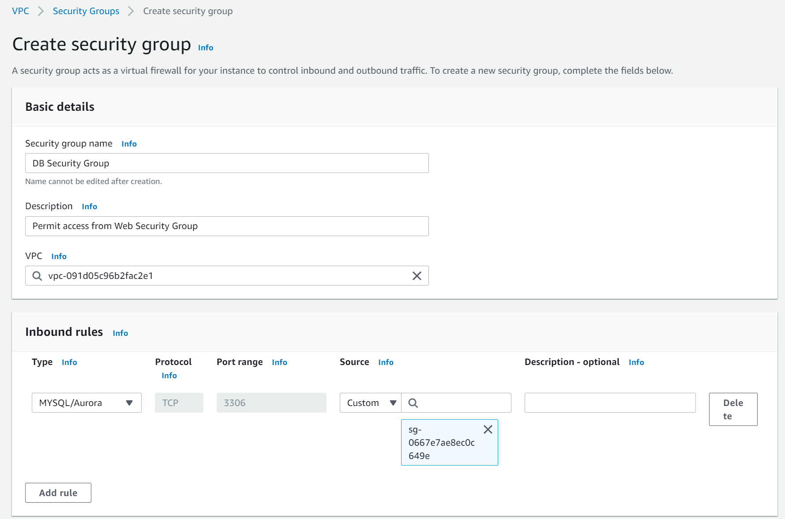

## **Task 2: Create a DB Subnet Group**

1. On the **Services** menu, choose **RDS**
2. In the left navigation pane, choose **Subnet groups.**

Choose Create DB Subnet Group the configure:

* + **Name:** DB-Subnet-Group
  + **Description:** DB Subnet Group
  + **VPC***:* Lab VPC

1. Add Subnets

**Availability Zones** select **us-east-1a** and **us-east-1b**

**Subnets** select **10.0.1.0/24** and **10.0.3.0/24**.

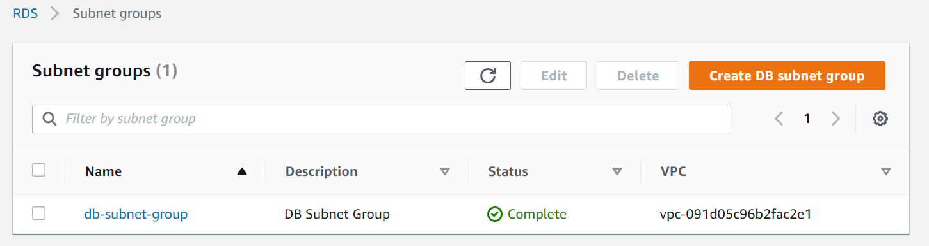

## **Task 3: Create an Amazon RDS DB Instance**

**Windows Users: Using SSH to Connect**

1. In the left navigation pane, choose **Databases**
2. Choose Create database
3. Select MySQL,
4. Under **Settings** configure:

* **DB instance identifier:** lab-db
* **Master username:** main
* **Master password:** lab-password
* **Confirm password:** lab-password

1. Under **DB instance class**, configure

* Select **Burstable classes (includes t classes)**.
* Select db.t3.micro

1. Under Storage, Configure

* **Storage type:** *General Purpose (SSD)*
* **Allocated storage:** *20*

1. Under Connectivity, Configure

* **Virtual Private Cloud (VPC):** *Lab VPC*

1. Under **Existing VPC security groups,**

* Choose *DB Security Group*.
* Deselect *default*.

1. Expand **Additional configuration, the configure**

* **Initial database name:** lab
* Uncheck **Enable automatic backups**.
* Uncheck **Enable encryption**
* Uncheck **Enable Enhanced monitoring**

1. Choose Create database

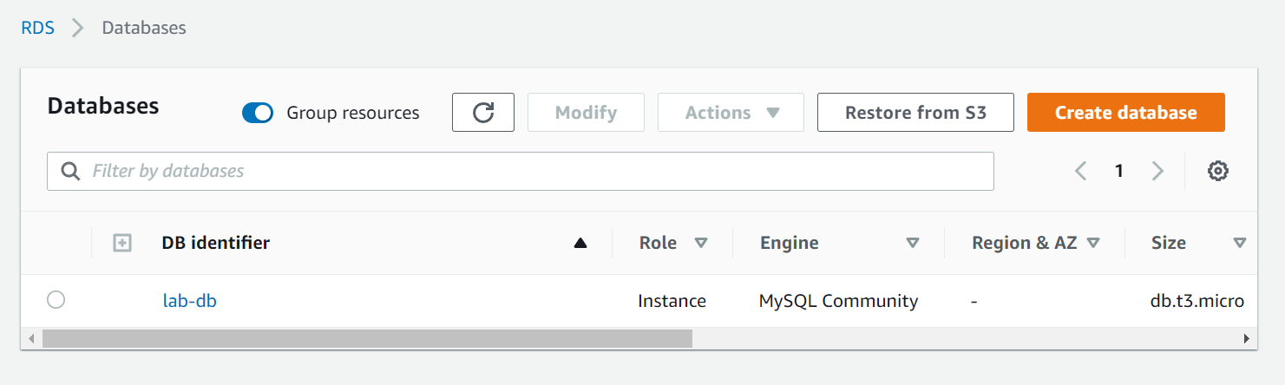

1. Choose **lab-db**
2. Wait until **Info** changes to **Modifying** or **Available**
3. Scroll down to the **Connectivity & security** section and copy the **Endpoint** field
4. Save Endpoint Values

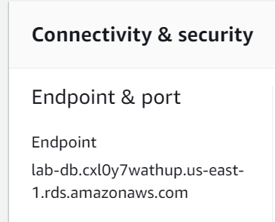

## **Task 4: Interact with Your Database**

1. Choose **Details** drop down and choose **Show** copy the **WebServer** Ip address
2. Open a new web browser tab, paste then enter the **WebServer** Ip address
3. Choose RDS link and configure the following settings:

* **Endpoint:** Paste the Endpoint you copied to a text editor earlier
* **Database:** lab
* **Username:** main
* **Password:** lab-password
* Choose **Submit**

1. Test the web application by adding, editing, and removing contacts.

The data is being persisted to the database and is automatically replicating to the second Availability Zone.